**Digital Broker System**

A Software Engineering Project Submitted

By

|  |  |  |  |  |
| --- | --- | --- | --- | --- |
| **Semester: Summer_21_22** | | **Section: F** | **Group Number: 06** | |
| SN | Student Name | Student ID | Contribution (CO1+CO2) | Individual  Marks |
| 01 | Rudra,Arnob Saha | 20-42666-1 |  |  |
| 02 | Karim,Md. Fahimul | 18-36416-1 |  |  |
| 03 | Riaz Sarker | 20-42362-1 |  |  |
| 04 | Asmaul Husna Jarin | 20-42363-1 |  |  |
| 05 | Mushfiq Qayyum | 17-33170-1 |  |  |

**PROJECT PROPOSAL**

1. **Background to the Problem**

If anyone wants to exchange their assets in our country, they face different difficulties like fake documents, scam, over pricing, hassle in agreements etc. To remove these hassles, we introduced our platform. It will remove all these hassles in buying and selling assets.

1. **Solution to the Problem**

One step solution to find buyer & seller anywhere across the country to exchange their assets without any hassle. A platform where we will provide real buyers & sellers with appropriate agreements and also ensure its fulfillment & validity. We will provide a strong verification, proper agreement. We are looking for highly motivated buyers and sellers to boost our customer community. It will help our clients to maximize the productivity of money by minimizing the hassle in asset exchange. We have some competitors like B.property, Bikroy.com etc. They don’t verify every single user and mostly they deal with property related buying & selling issues. But we will deal with any asset like Shares, Gold, Bond, Property, Insurance, Vehicles etc.

**Functions and their specification**

1. **Registration/ Create account**

* Go to registration
* Enter The name, mail, phone
* Details to verify user
* Set password
* Priority Level: High
* Precondition: user have username and password

1. **Login:**

* The software shall allow users to login with their given username and password.
* The login credentials (username and password) will be verified with database records.
* If the login is successful the home page of the user account will be displayed.
* If the username and/or password has been inserted wrong, the random verification code
* will be generated and sent to the user’s email address by the system to retry login.
* If the number of login attempt exceed its limit (3 times), the system shall block the user
* account login for one hour [optional function]
* Priority Level: High
* Precondition: user have valid user name and password

1. **Profile:**

* Pay to update profile
* Details about that person
* Details about your product
* Confirm updates
* Budget setting
* Media
* Notifications
* search
* Communications
* Accounts for financial statement
* payment
* Logout
* Precondition: user have valid Login updated profile

1. **Notification:**

* Click bar
* Details of any updates
* Priority Level: low
* Precondition: updated profile

1. **Search:**

* **Search: for buyer**
* Budget specification
* Market specification
* Pay for search
* Priority Level: High
* Precondition: user has valid user id , password, updated profile,Pay for search (package).
* **Search: for seller**
* Budget specification
* Market specification
* Priority Level: High
* Precondition: user has valid user id , password, updated profile, Pay for search (package).

1. **communication:**

* Pay to communicate others
* Block
* Send
* Unsend
* Show documents
* Refer previous communication
* Like or dislike comments
* Priority Level: High
* Precondition: user has valid user id,Pay to communicate with others(package).

1. **Accounts/ Financial statement:**

* Bank Statement
* Income Fund Source
* Must have a valid Bank/Mobile bank Account .

1. **Payment:**

* Select any package for (Profile, Search, Communicate,Agreement)
* Bkash, Nagad, Visa Card, MasterCard, Debit Card, American Express are the payment options
* User must have to select payment method from these payment methods
* If user select Visa Card, MasterCard, Debit Card, American Express then s/he need to provide card details
* After giving the payable amount S/He can proceed to make payment after clicking on the payment button
* After a successful payment user will get a confirmation message on his cell phone and also will get a notification on the website
* If user select Bkash or Nagad, then s/he need to provide her/his Bkash or Nagad number
* Then user need to give the payable amount
* After that user need to provide her/his Bkash or Nagad pin number in order to make the payment
* Then user can proceed to make payment after clicking on the payment button
* After a successful payment user will get a confirmation message on his cell phone and also will get a notification on the website
* Priority Level: High
* Precondition: user must have to Choose an package and payment method

1. **Agreement:**

* Sellers must upload their selling documents or agreements to verify its authentication before any sale advertisement. Admin should verify his/her uploading documents to insure its validity.
* Buyer must verify his/her identity with supported documents to register themselves into the system as a buyer/seller. Admin can also verify his/her identity and approve his/her registration.
* If any seller/buyer doesn't verify their information with a valid document,He/she can’t register into the system.
* Admin reserves the right to change or delete any information if any false information is found.
* Pay to Close Agreement
* Priority Level: High
* Precondition: user has valid user Pay to Close Agreement

1. **Logout:**

* Logout from account
* Show login page again for reconnecting

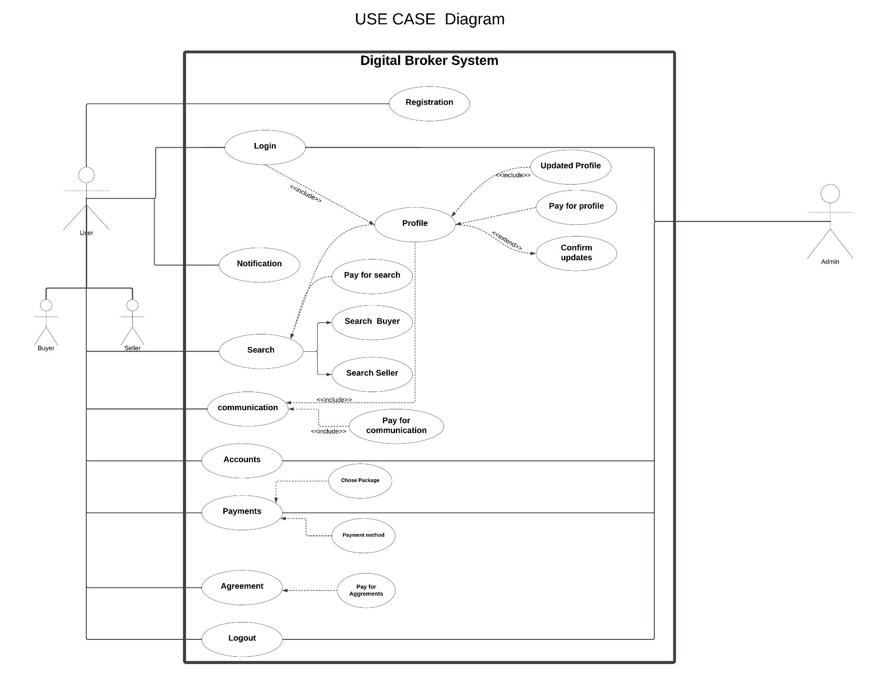

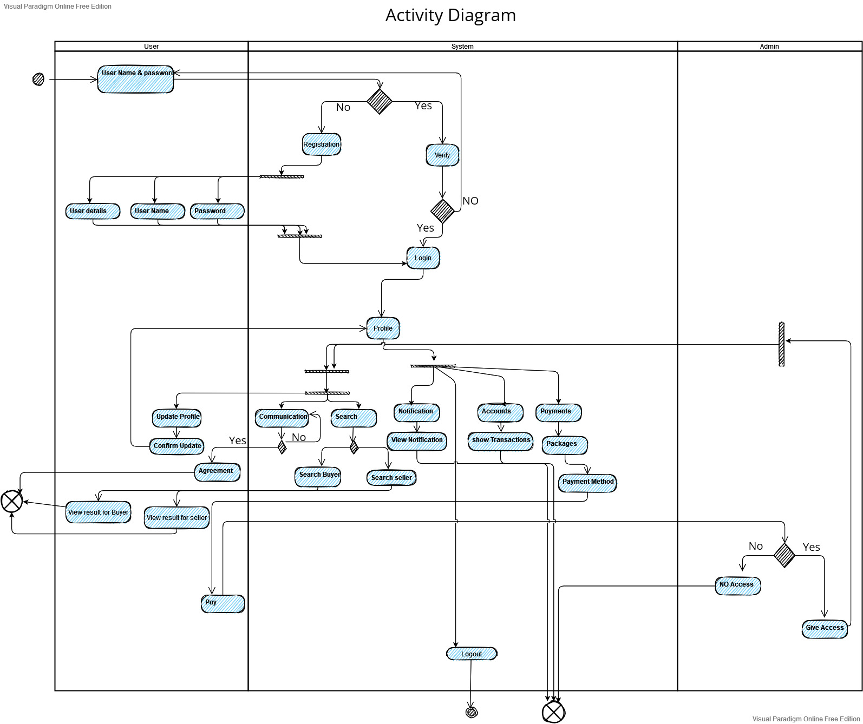

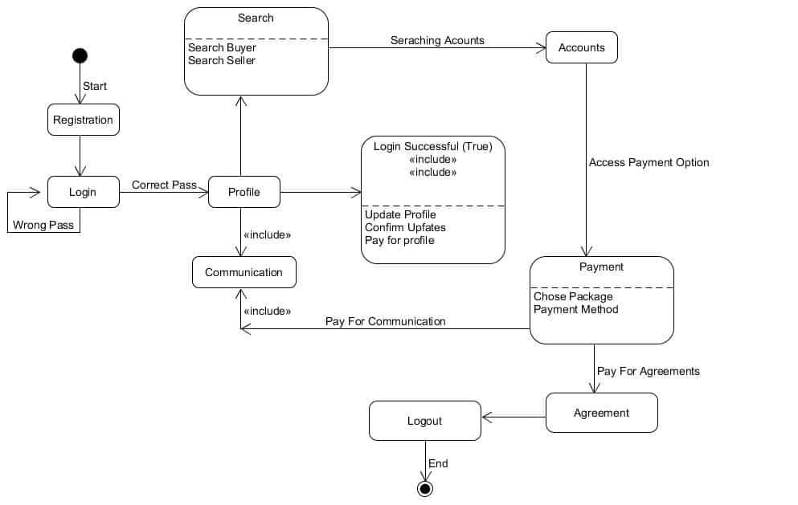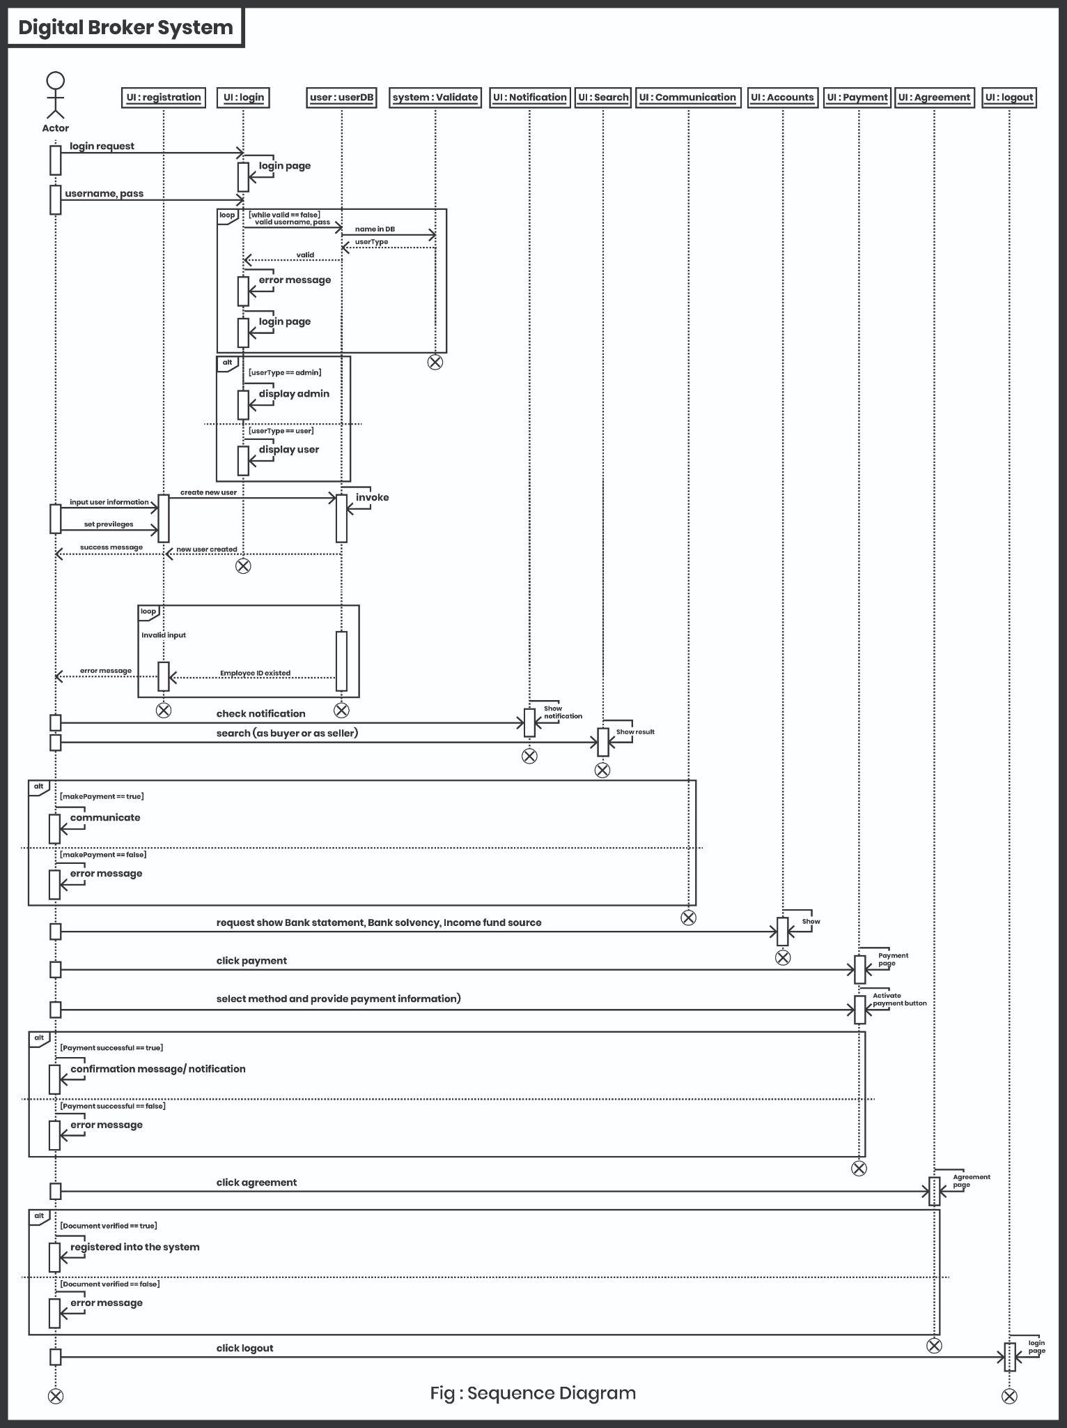

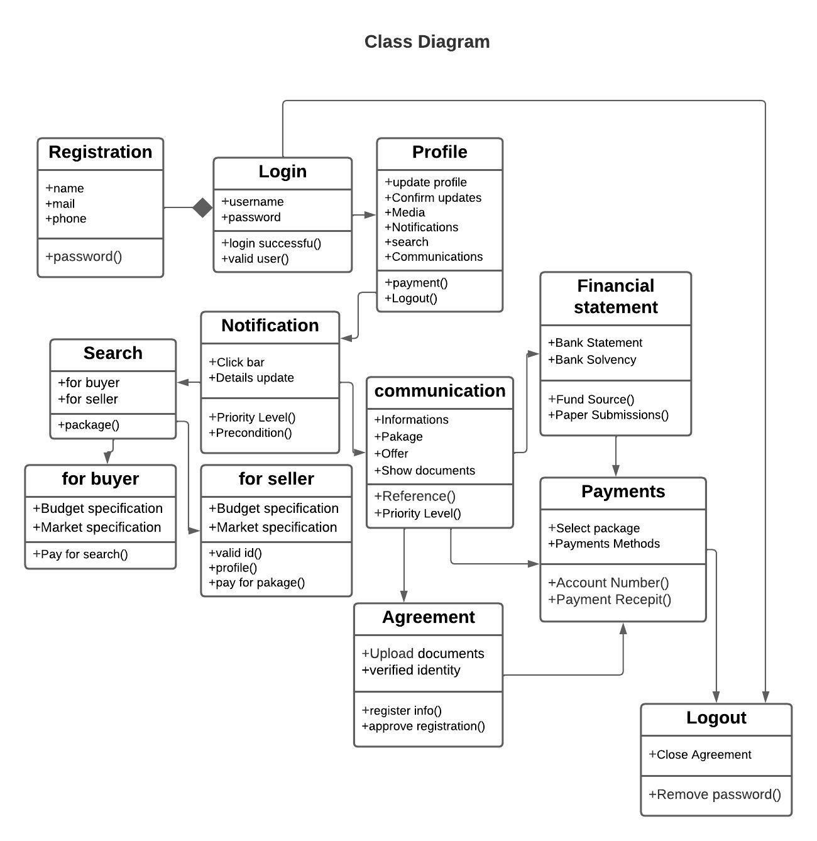

**Process Model:** Scrum framework will be used for ’Digital Broker’. Scrum is an Agile methodology consisting of lightweight management practices that have relatively little overhead. Scrum is based on three pillars: Transparency, Inspection, and Adaptation. It helps teams work together and develop an impactful project in a short period .

Scrum Process Model :

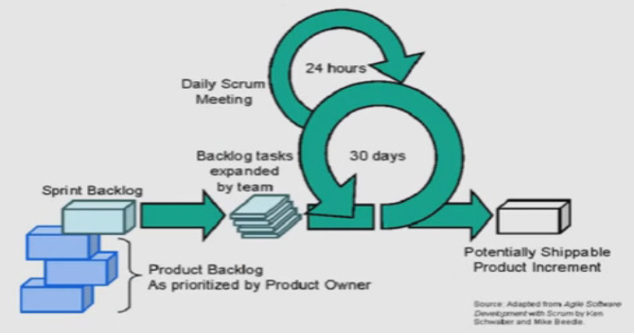

Scrum uses an approach that is both iterative and incremental. Which will help ‘Digital Broker’ in these way

* Scrum can help teams complete project deliverables quickly and efficiently
* Scrum ensures effective use of time and money
* Large projects are divided into easily manageable sprints
* Developments are coded and tested during the sprint review
* Works well for fast-moving development projects
* There are frequent assessments of the project, which enhances predictability and mitigates risk.
* scrum points out everything developers are NOT doing right.

The Waterfall model is best for projects with rigid rules and structures, fixed scope, deadline, and budget. On the other hand, Agile is suitable if the project depends on getting to market first and then iterating upon customers' feedback. However, if you prefer structure within your Agile model that guides your team to follow some defined rules, then Scrum is the best model. That is why we prefer Scrum for ‘Digital Broker’ .

**SYSTEM UI DESIGN (PROPOSED)**

**Log in & Registration**

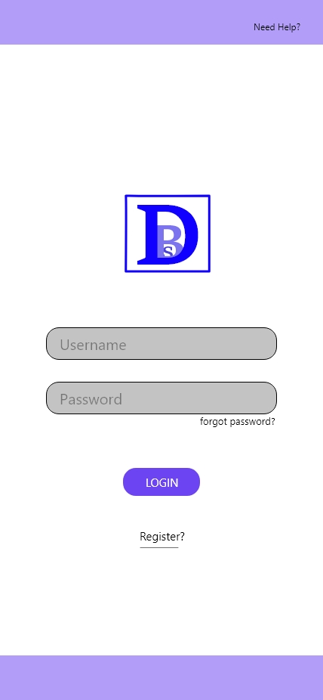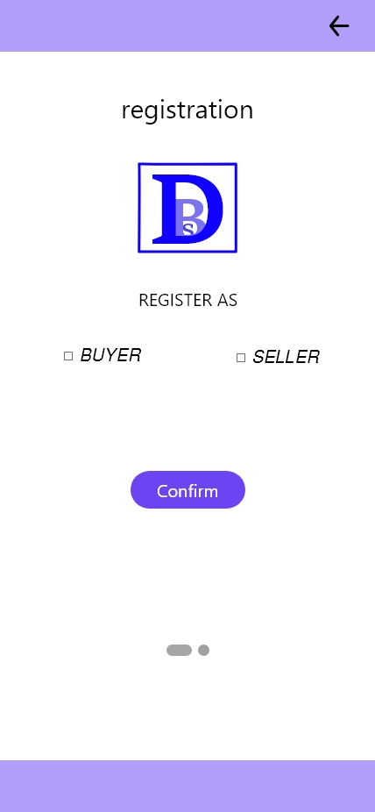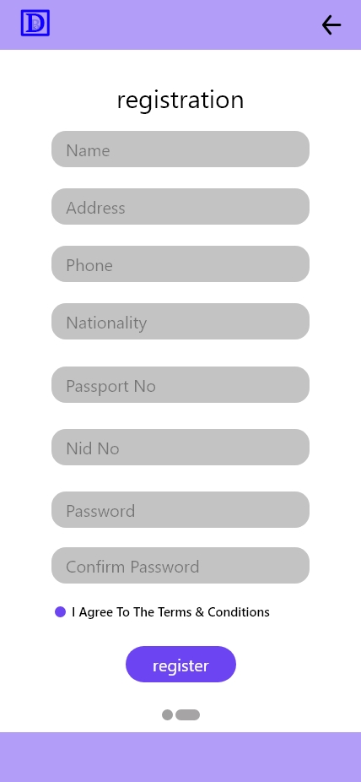

**Profile**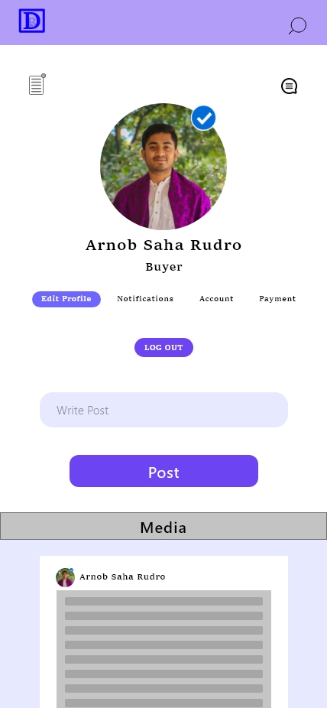

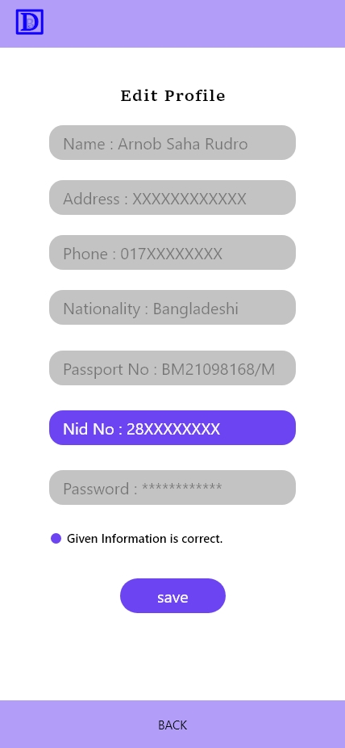

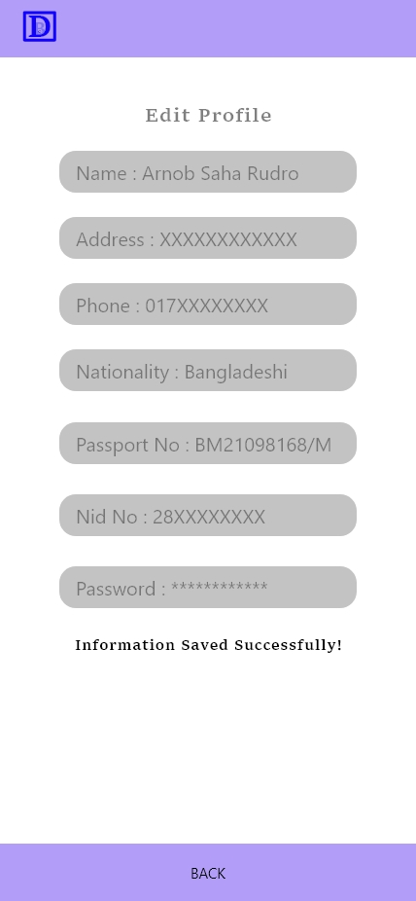

**Notification**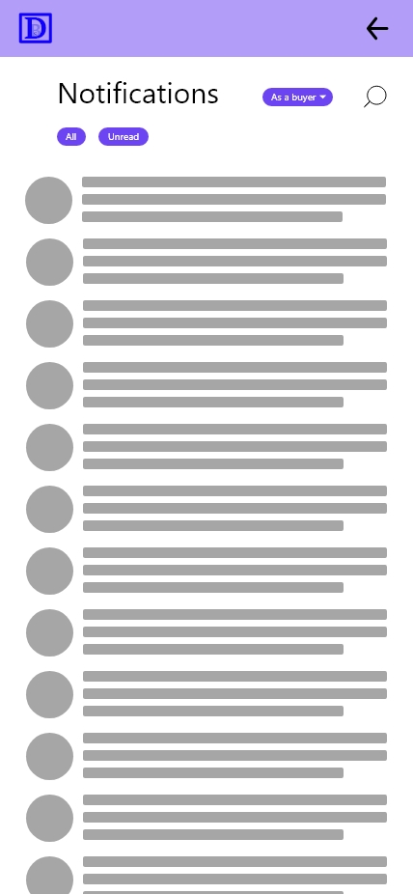

**Communication**

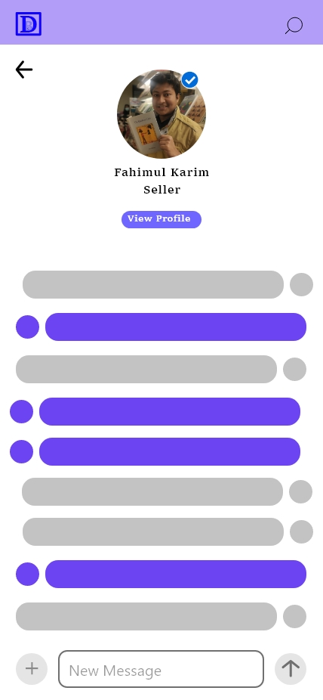

**Accounts/ Financial statement**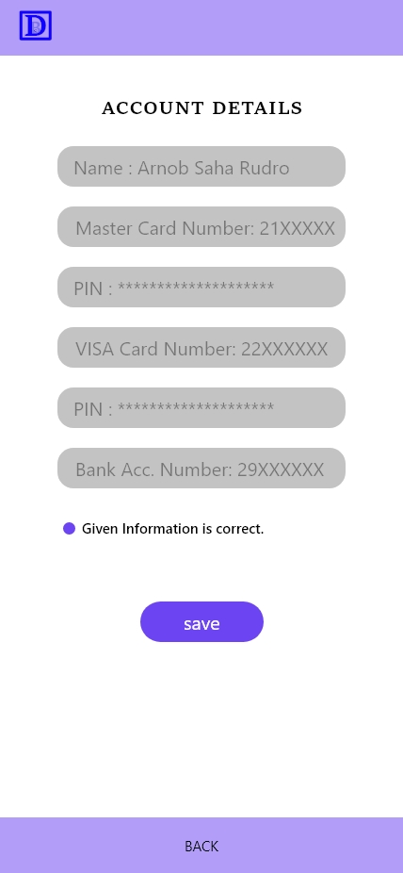

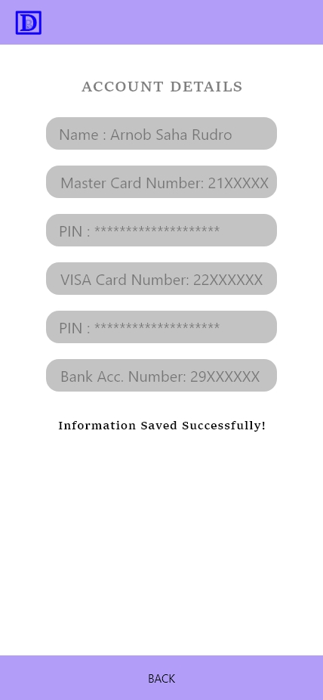

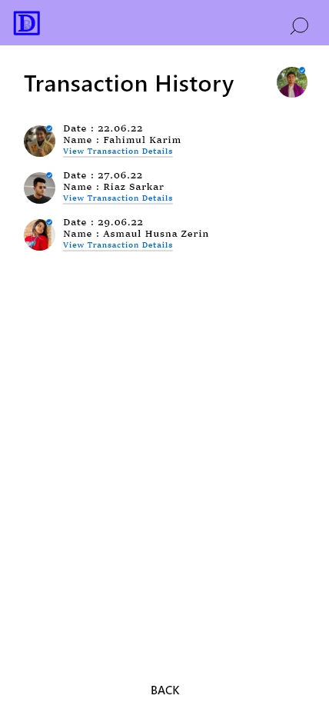

**Payment**

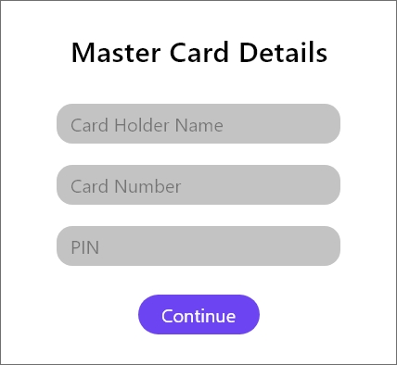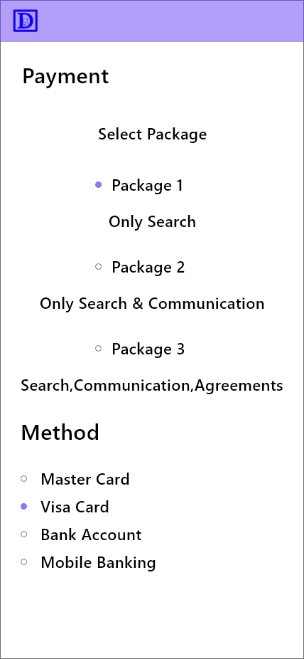

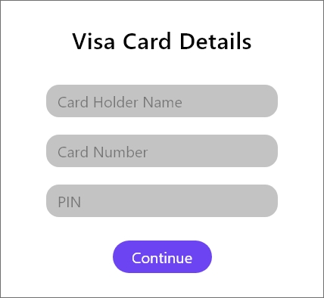



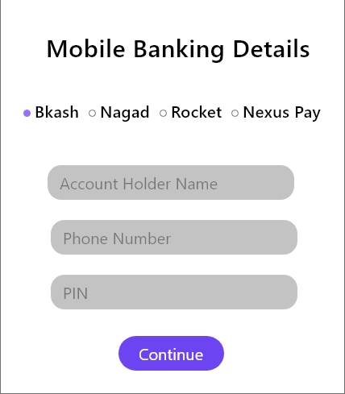

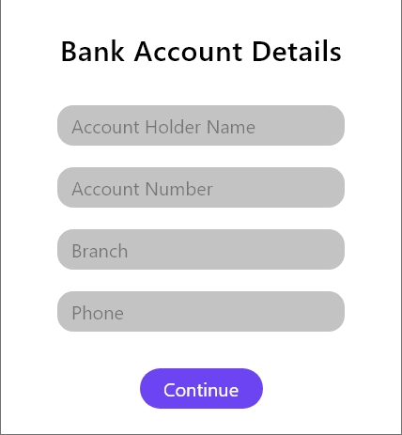

**Search**

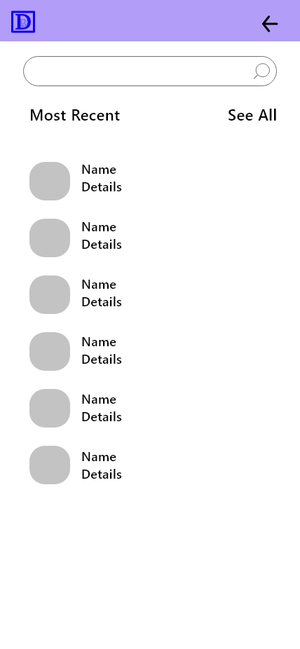

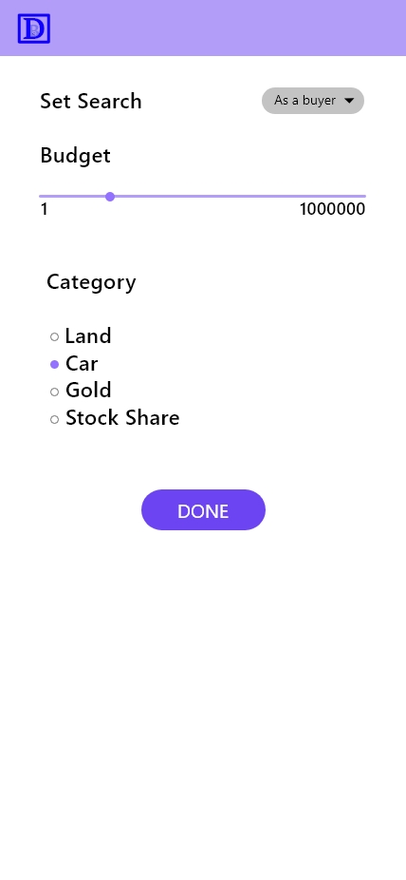

**Profile Visit**

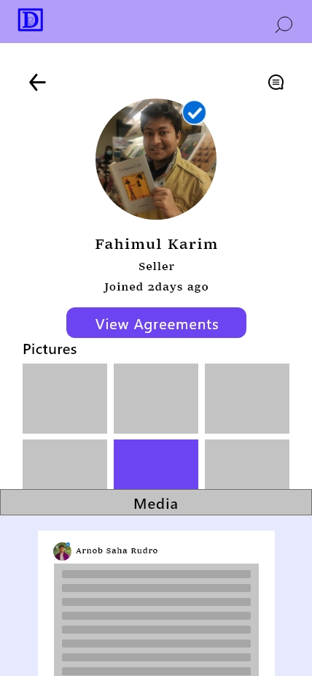

**Agreement**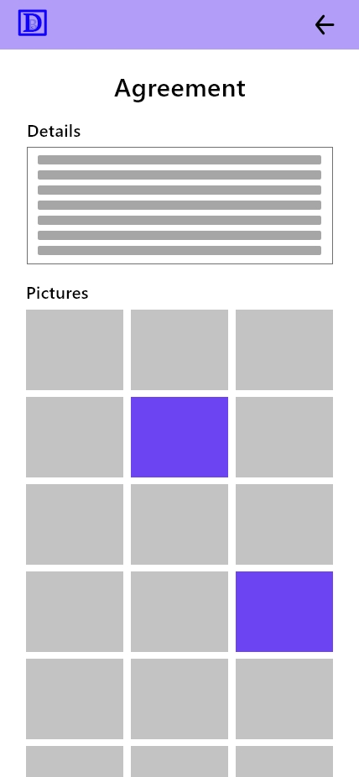

|  |  |
| --- | --- |
| Project Name: Digital Broker System | Test Designed by: Riaz |
| Test Case ID: FR_1001 | Test Designed date:19.07.22 |
| Test Priority (Low, Medium, High):Medium | Test Executed by:Fahimul |
| Module Name: Accounts | Test Execution date:19.07.22 |

|  |
| --- |
| Test Title: Verify Accounts functionality |
| Description:Test Accounts of Digital Broker System App |
| Precondition (If any): Must have a valid Bank/Mobile bank Account . |

|  |  |  |  |  |
| --- | --- | --- | --- | --- |
| Test Steps | Test Data | Expected Results | Actual  Results | Status  (Pass/Fail) |
| 1. Go to accounts from profile  2.Set Bank Account Information  3.Saved Bank Account Information  4.Show Bank Statement  5.Show income source | View Transaction History  View Transaction Details | User should able to View Bank Statement and  Income Fund Source | Satisfied | Pass |

|  |
| --- |
| Post Condition: Users can see each and every detail about their Bank/ Mobile Bank account. |

|  |  |
| --- | --- |
| Project Name: Digital Broker System | Test Designed by:Fahimul |
| Test Case ID: FR_1002 | Test Designed date:19.07.22 |
| Test Priority (Low, Medium, High):High | Test Executed by: Riaz |
| Module Name:Payment | Test Execution date:19.07.22 |

|  |
| --- |
| Test Title:Verify Payment Method |
| Description:Test App Test payment Method for Digital Broker System App |
| Precondition (If any):Must have a valid Bank/Mobile bank Account Logedin. |

|  |  |  |  |  |
| --- | --- | --- | --- | --- |
| Test Steps | Test Data | Expected Results | Actual  Results | Status  (Pass/Fail) |
| `1. Go to payment from profile  2.select Package  3.select method  4. Pay | Click Payment  Select Package  Select payment method | User can Select any package for (Profile, Search, Communicate,Agreement)  User must have to select payment method from all payment methods  Successful Payment | As expected | Pass |

|  |
| --- |
| Post Condition: Show payment history in Accounts to the user |

|  |  |
| --- | --- |
| Project Name: Digital Broker System | Test Designed by:Fahimul |
| Test Case ID: FR_1003 | Test Designed date: 21/07/22 |
| Test Priority (Low, Medium, High): High | Test Executed by: Mushfiq Qayyum |
| Module Name: Registration | Test Execution date: 21/07/22 |

|  |
| --- |
| Test Title: Verify registration system |
| Description:Test App registration system for Digital Broker System App |
| Precondition (If any): user must have a unique username and a password |

|  |  |  |  |  |
| --- | --- | --- | --- | --- |
| Test Steps | Test Data | Expected Results | Actual  Results | Status  (Pass/Fail) |
| 1. Go to Digital Broker System App 2. Confirm his/her role as Buyer or Seller 3. Provide all the information into the registration page 4. Click the checkbox of terms and conditions 5. Click on the register button | Name: Riaz Sarker  Address: Dhaka, Bangladesh  Phone: 01954069336  Nationality: Bangladeshi  Passport No: 1111  NID No: 2222  Password:  12345  Confirm Password:  12345 | User should be registered into the system | As expected | Pass |

|  |
| --- |
| Post Condition: Show the confirmation of successful registration |

|  |  |
| --- | --- |
| Project Name: Digital Broker System | Test Designed by: Riaz |
| Test Case ID: FR_1004 | Test Designed date: 21/07/22 |
| Test Priority (Low, Medium, High): Medium | Test Executed by: Mushfiq Qayyum |
| Module Name: Login | Test Execution date: 21/07/22 |

|  |
| --- |
| Test Title: Verify login system |
| Description:Test App login system |
| Precondition (If any): user must have a valid username and a password |

|  |  |  |  |  |
| --- | --- | --- | --- | --- |
| Test Steps | Test Data | Expected Results | Actual  Results | Status  (Pass/Fail) |
| 1. Go to Digital Broker System App 2. Enter correct username and password 3. Click on the login button | Username: riaz sarker  Password:  12345 | User should be logged in into the system | As expected | Pass |

|  |
| --- |
| Post Condition: Successful login confirmation will be displayed and user will be redirect to his/her profile |

|  |  |
| --- | --- |
| Project Name: Digital Broker System | Test Designed by: Riaz |
| Test Case ID: FR_1005 | Test Designed date:21.07.22 |
| Test Priority (Low, Medium, High):High | Test Executed by:Zerin |
| Module Name:Profile | Test Execution date:21.0722 |

|  |
| --- |
| Test Title:Verify Profile |
| Description:Test App Profile |
| Precondition (If any): Successful Registration and Login |

|  |  |  |  |  |
| --- | --- | --- | --- | --- |
| Test Steps | Test Data | Expected Results | Actual  Results | Status  (Pass/Fail) |
| 1.view Profile function after login  2. Search  3.View Notification  4.Edit Profile.  5.Logout works  6.Check Communication  7.check account  8.Check Payment  9. Write post | Profile found for both buyer and seller Profile and every other functions | Found Users Profile and can access all other functions | As expected | Pass |

|  |
| --- |
| Post Condition: Every function works properly and can exit from every state |

|  |  |
| --- | --- |
| Project Name: Digital Broker System | Test Designed by: Riaz |
| Test Case ID: FR_1006 | Test Designed date: 21.07.22 |
| Test Priority (Low, Medium, High): High | Test Executed by: Rudro |
| Module Name: Search : Search For Buyer | Test Execution date: 21.07.22 |

|  |
| --- |
| Test Title: Search : For Buyer |
| Description:Test App Searching Option |
| Precondition (If any): user has valid user id,password,updated profile,Pay for search (package) |

|  |  |  |  |  |
| --- | --- | --- | --- | --- |
| Test Steps | Test Data | Expected Results | Actual  Results | Status  (Pass/Fail) |
| go to Digital Broker System App.  then login to the app using a valid username and password.  go to the Profile Section & Enter to the search option.  At first you can pay for accessing search options. Then you can search & you can set search manually. | [I am searching a seller profile]  Profile Name : Fahimul Karim | Search Found. | As expected | Pass |

|  |
| --- |
| Post Condition: If the searching data is found then it will be displayed and user will be redirect to that |

|  |  |
| --- | --- |
| Project Name: Digital Brokar System | Test Designed by:Fahimul |
| Test Case ID: FR_1007 | Test Designed date: 21.07.22 |
| Test Priority (Low, Medium, High): High | Test Executed by: Rudro |
| Module Name: Search : For Buyer | Test Execution date: 21.07.22 |

|  |
| --- |
| Test Title: Search : For Buyer |
| Description:Test App Searching Option |
| Precondition (If any): user has valid user id , password, updated profile, Pay for search (package) |

|  |  |  |  |  |
| --- | --- | --- | --- | --- |
| Test Steps | Test Data | Expected Results | Actual  Results | Status  (Pass/Fail) |
| go to Digital Broker System App.  then login to the app using a valid username and password.  go to the Profile Section & Enter to the search option.  At first you can pay for accessing search options. Then you can search & you can set search manually. | [I am searching a buyer profile]  Profile Name : Riaz Sarker | Search Found. | As expected | Pass |

|  |
| --- |
| Post Condition: If the searching data is found then it will be displayed and the user will be redirected to that search. |

|  |  |
| --- | --- |
| Project Name: Digital Brokar System | Test Designed by:Fahimul |
| Test Case ID: FR_1008 | Test Designed date: 23-07-2022 |
| Test Priority (Low, Medium, High): High | Test Executed by: Riaz Sarker |
| Module Name: Communication | Test Execution date:23-07-2022 |

|  |
| --- |
| Test Title: Communication |
| Description:Test Communication of Digital Broker System App |
| Precondition (If any): User must complete their deal with clear communication. |

|  |  |  |  |  |
| --- | --- | --- | --- | --- |
| Test Steps | Test Data | Expected Results | Actual  Results | Status  (Pass/Fail) |
| 1. Go to Digital Broker System App 2. Select Seller or buyer id. 3. Provide all the information for selling or buying products. 4. Communication must be continued respectfully. | Id found  Communicate with other buyers/sellers | Communicate with others | As expected | Pass |

|  |
| --- |
| Post Condition: Users can see each and every detail about their Communications. |

|  |  |
| --- | --- |
| Project Name: Digital Brokar System | Test Designed by: Riaz Sarker |
| Test Case ID: FR_1009 | Test Designed date:23-07-2022 |
| Test Priority (Low, Medium, High): High | Test Executed by: Riaz Sarker |
| Module Name: Agreement | Test Execution date:23-07-2022 |

|  |
| --- |
| Test Title: Agreement |
| Description: Test Agreement of Digital Broker System App |
| Precondition (If any): User must have full-filled their Agreement. |

|  |  |  |  |  |
| --- | --- | --- | --- | --- |
| Test Steps | Test Data | Expected Results | Actual  Results | Status  (Pass/Fail) |
| 1.Go to Digital Broker System App  2.Select Seller or buyer id.    3. Select product for buy or sell with legal agreement.  4. Agreement should be completed with each person's wishingly. | Clauses are not ready to serve  Not pre defined every time | Found required clauses | Not up to the mark | Fail |

|  |
| --- |
| Post Condition: Users can see each and every detail about their necessary Agreement for deal. |

|  |  |
| --- | --- |
| Project Name: Digital Brokar System | Test Designed by:Fahimul |
| Test Case ID: FR_1010 | Test Designed date: |
| Test Priority (Low, Medium, High):Medium | Test Executed by:Zerin |
| Module Name:Notification | Test Execution date:21.07.21 |

|  |
| --- |
| Test Title:verify notification function |
| Description:Test App Notification |
| Precondition (If any): |

|  |  |  |  |  |
| --- | --- | --- | --- | --- |
| Test Steps | Test Data | Expected Results | Actual  Results | Status  (Pass/Fail) |
| 1.Login  2.Check notification from profile | Check notification | Get notification | AS Expected | Pass |

|  |
| --- |
| Post Condition: can exit and can move to communication |

**Work Breakdown Structure**

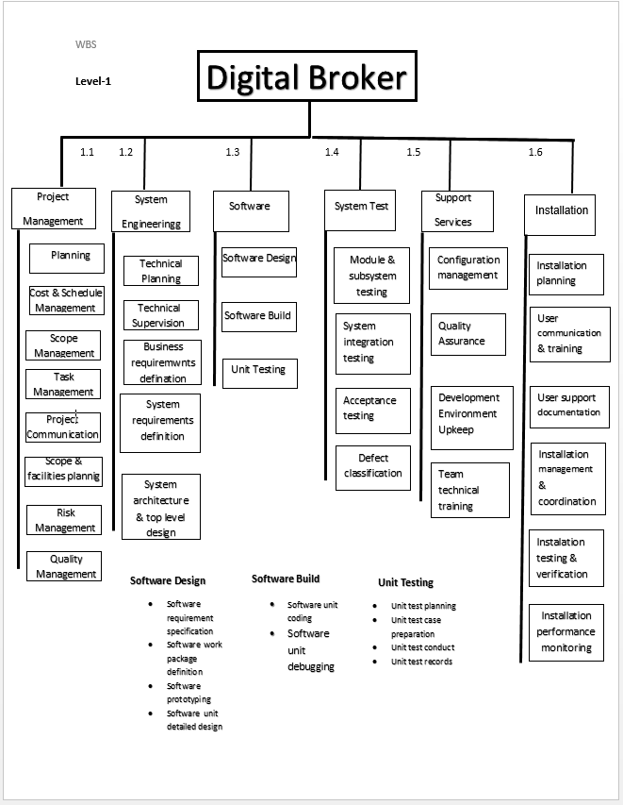

Effort = PM = Coefficient <Effort fector> **\*(SLOC x 1000)**p

PM = 2.4 x (3000/1000) 1.05

= 7.6months

(Duration )-> DM = 2.50 x (7.6)0.38

= 5.4months

ST= 7.6/5.4

= 1.4

= 2

We will require 3 people to complete this work . and our time line charts are

**Timeline Chart1**

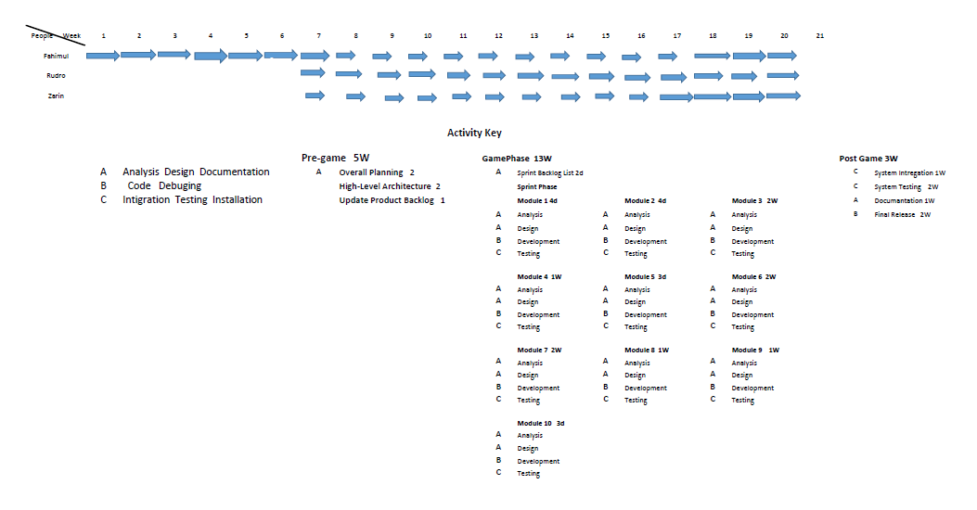

**TimeLine chart 2**

